Safeguarding Newsletter- February 2018
Dear Parent/Guardian
The information below is designed to familiarise you with the most recent safeguarding concerns that are being faced by all schools. South Dartmoor is committed to safeguarding and promoting the welfare of children and we will continue to provide materials for parents and carers outlining how schools, the Health Service, Police, Social Care and parents can work together to keep children safe. It is key to remember that safeguarding children is everyone’s responsibility, everyone’s concern and everyone’s business.
All of the College’s updated safeguarding policies and procedures are available on the Child Protection and Safeguarding section of the College website, and we encourage all parents to view these documents to get an understanding of how South Dartmoor continues to keep children safe.
http://www.southdartmoor.devon.sch.uk/page/?title=Child+Protection+and+Safeguarding&pid=74
We would advise all parents and carers to read the Child Protection and Safeguarding policy 2017-18 and the September 2016 Keeping Children Safe in Education document. Please use the link above to access the College’s new policies.
What’s new – Year 7 THINK cards
As part of the College's mental health and well-being strategy, Year 7 students this month have been looking at implementing THINK questions into all their communications with others:
THINK
T = is it true?
H = is it helpful?
I = is it inspiring?
N = is it necessary?
K = is it kind?
We will be asking students to think about how to be kind to each other through inevitable changes of friendships and social groups and about the potential damaging effects of isolation and lack of friendship. As part of the ongoing Anti-bullying strategy we have made students, through assemblies and tutorials about the tragic consequences of bullying reported recently on the national news.
This stage of Year 7 can be difficult for students as they form their new friendship groups. Consequently, we have created laminated cards will support them to manage this better. As part of the THINK initiative we will also be asking students to think about how they can better their day to day mental well-being.
ENCOUARGING BETTER MENTAL HEALTH
1. Talk about your feelings
2. Keep yourself hydrated
3. Eat well
4. Take a break from electrical gadgets
5. Sleep well
National Headlines – Children’s Commissioners report into social media use
Most social media platforms have a minimum age limit of 13, but research shows a growing number of children aged under 13 are using social media, with 3 in 4 children aged 10-12 having their own accounts.
While much is known about how teenagers use social media, this research provides the missing piece to the story, exploring the social media lives of children before they reach the teenage years. In October and November 2017, we conducted 8 focus groups with 32 children aged 8-12 to understand the impact of social media on the wellbeing of this age group
Across all ages, the most popular social media were Snapchat, Instagram, Musical.ly and WhatsApp. The report found that one third of current internet users were under the age of 18. Whilst most social media sites have an official age limit of 13 years, research is increasingly reporting the accessing and use of these sites by children under 13.
Table 1. The social media used by Year 6 and Year 7 groups, and how often children used them.
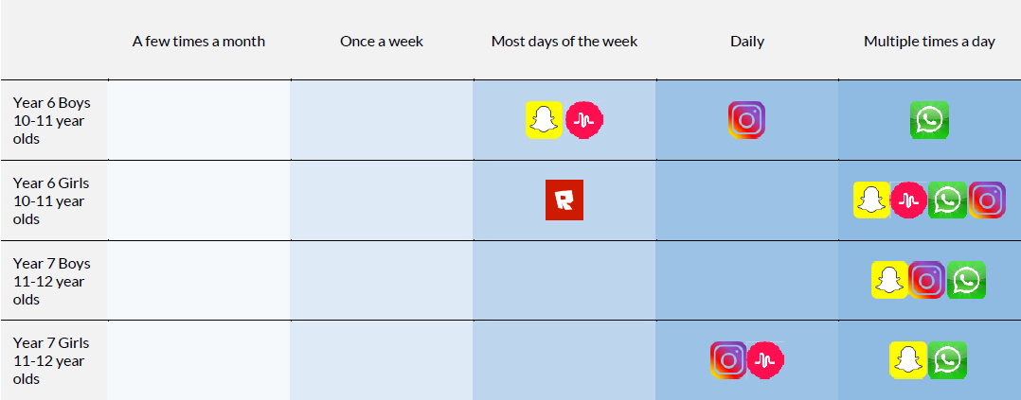
Age restrictions
- Twitter doesn’t ask your age when you sign up
- Facebook is 13
- Instagram, Pinterest, Tumblr, Reddit, Musical.ly, Roblox, Snapchat and Secret is 13
- LinkedIn is 14.
- WhatsApp is 16
- Vine it’s 17.
- Some platforms, such as YouTube, WeChat and Kik, have a minimum age required of 18, although children aged 13-17 can sign up with parent’s permission.
The College would advise parents and carers to check and monitor the types of social media platforms that are being accessed by their sons/daughters. We would also encourage parents to support their children to take part in other alternative activities. Research shows that children who take part in hobbies, sports or other activities are less reliant on social media. There is also a direct link between improvements in mental health and well-being in regards to limiting the access to technology.
Please use the link below to access the full Commissioners report.
https://www.childrenscommissioner.gov.uk/wp-content/uploads/2018/01/Childrens-Commissioner-for-England-Life-in-Likes.pdf
Monthly technology focus – Dangerous apps & websites
The apps and websites described below have recently appeared in Child Sexual Exploitation or Abuse cases in the Southwest region for the month stated above.
Bigo Live is a live-streaming video app made by a Singaporean team, connected to the Chinese YY social network, and as such resonates a lot more with young people in Southeast Asia, however is starting to make a ripple in the UK. Users range from teenagers to twentysomethings and the broadcasts mostly feature them going about their lives, just with a camera pointed at them. Conversations go on between users and the broadcaster.
Chatrandom is a live streaming website much like the popular sites omegle and chatroulette. The website matches two random people via webcam to make new friends, however this can be exploited in many ways. The case study below is an example of how young people are being exploited on the site.
Yellow app - The makers of a controversial app, which the NSPCC fears could put children at risk of predators, have told Sky News they are developing tools "to avoid deviant behaviours". Yellow has been compared to the dating app Tinder, as user’s swipe right and left on profiles to connect with strangers. Unlike Tinder, which has a minimum age of 18, Yellow has no age checks.
Advice and guidance
The UK safer internet centre; where you can find e-safety tips, advice and resources to help children and young people stay safe online. For help and advice contact: 0344 3814772 or helpline@saferinternet.org.uk
Childline and the Internet Watch Foundation have come together to provide a service where children can request the removal of sexual images of themselves which have been shared online. As part of that process the child would be asked to provide a link to where the image is stored online, rather than send the image itself.
The child is also required to verify their identity and age and this is done through the YOTI app. YOTI will not store images of the child’s ID following the verification process.
Below are a couple of online resources which contain details regarding this service:
https://www.nspcc.org.uk/preventing-abuse/keeping-children-safe/sexting - There is a section which covers what you can do if you’ve lost control of a sexual image and refers to the YOTI app.
https://contentreporting.childline.org.uk – This is the portal where you can report images and videos for take down and again refers to using the app to verify age.
CEOP works with child protection partners across the UK and overseas to identify the main threats to children and coordinates activity against these threats to bring offenders to account. We protect children from harm online and offline, directly through partnerships with local and international agencies. I have placed a direct reporting link to CEOP (image below to look for on the College website) on our safeguarding pages of the College website.
https://www.ceop.police.uk/ceop-reporting/
https://www.ceop.police.uk/Safety-Centre/Should-I-make-a-report-to-CEOP-YP/

Reporting safeguarding concerns

If you have concerns about terrorism you must call your concern through to:
- Anti-Terrorist Hotline: 0800 789 321

- Crime stoppers: 0800 555 111

- (South West) Police 101

- Dan Vile, Designated Safeguarding Lead: College number – 01364 652230

Parents are, as always, asked to report safeguarding concerns to the College so that we can provide support and guidance and, where necessary, access external agency support. Safeguarding concerns can be reported to your son/daughter’s Performance Leader or directly to me as the Designated Safeguarding Lead.
May I remind all parents that the College has a reporting button on the College website which enables students and parents to report concerns to the College anonymously? We do encourage parents and students to use the report button to give specific details of the event to facilitate a faster resolution.
If you have any safeguarding concerns during the holidays, and you need support, you are advised to speak to the Multi-Agency Safeguarding Hub (MASH). To find out more about the Multi-Agency Safeguarding Hub (MASH) please visit; www.devon.gov.uk/childprotection.
If you are concerned about a child or young person in Devon, and want to speak to someone, contact the MASH on 0345 155 1071 and give as much information as you can. Please see MASH information poster below.
Parents can also access confidential support and advice through, Child line 0800 1111
If you have any safeguarding questions in regards to the links included in the newsletter, or have questions about our safeguarding procedures at South Dartmoor, please do not hesitate to contact me directly.
Email: dvile@southdartmoor.devon.sch.uk Phone: 01364 652230

Yours faithfully,
Dan Vile
Designated Safeguarding Lead

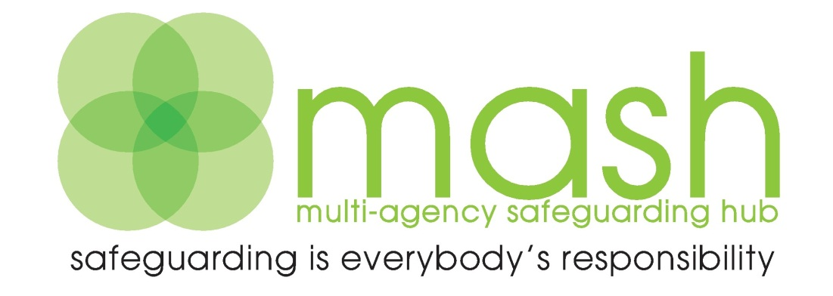
For Early Help, Consultation and Enquiries please contact:
Telephone: 0345 155 1071
E-mail: mashsecure@devon.gcsx.gov.uk
Fax: 01392 448951
Enquiry Form available at:
www.devon.gov.uk/mash-enquiryform.doc

Post: Multi-Agency Safeguarding Hub, P.O. Box 723, Exeter EX1 9QS

Emergency Duty Team – out of hours
0845 6000 388
Police – non emergency – 101

For all LADO enquiries Exeter (01392) 384964
Or
http://www.devon.gov.uk/lado

