What is EPQ?
EPQ stands for Extended Project Qualification, it is chosen as a YR13 option and will be completed after Easter. The EPQ can be related to any topic of your choice, it will usually be a topic related to one of your A Level subjects or chosen University/Apprenticeship course. The EPQ can be presented as an essay, performance or an artefact meaning that it is tailored to suit your needs. The essay must be 5000 words with a presentation to explain your process, whereas the performance/artefacts only require a 2500 word essay. The EPQ has a greater focus on the process rather than the outcome, meaning that the process of creating your project is just as valued as the outcome of the presentation.
Why choose EPQ?
- The EPQ is widely acknowledged by Universities as it demonstrates that you are a self-motivated learner and have the ability to conduct and analyse research.
- Demonstrates to Universities/Apprenticeship providers that you’re enthusiastic about the subject you’re applying to study.
- Allows you do grow as a person and a learner, students often find that their time management and analytical skills significantly improve after completing the EPQ.
- Helps with revision and exam technique as you become a self-motivated learner.

How many UCAS points is EPQ worth?
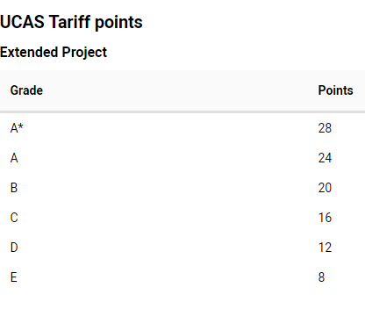
Useful links
https://www.birmingham.ac.uk/undergraduate/preparing-for-university/epq/faqs.aspx
https://qips.ucas.com/qip/extended-project-qualification-epq
https://www.ucas.com/connect/blogs/how-choose-epq-topic-and-title-epq-advice-2

