South Dartmoor
College Uniform

Uniform agreement

The uniform at South Dartmoor is a symbol of your aspiration to excellence and high achievement.
Your appearance is a measure of your self-discipline. It reflects your pride and commitment to being a member of the College, and is a visible sign of your readiness to learn.
We expect you to wear your uniform correctly and smartly at all times, including when you are travelling to and from college.
South Dartmoor Community College Blazer must be worn during the following times:
- moving about the site between lessons.
- in assembly.
- in lessons, unless permitted by class teacher to be removed upon request.
- when arriving at and leaving the canteen at lunch and break time.
- Year 7 will be issued with the new College blazer with the new College logo.
White shirt with collar and sleeves that buttons up to the collar and is of sufficient length to stay tucked in
College tie: Students must wear their College ties correctly: the point of the tie must touch the waistband of the trousers or skirt, and the knot must cover the fastened top button of the shirt.
FORMAL pressed, plain black trousers for Boys and Girls:
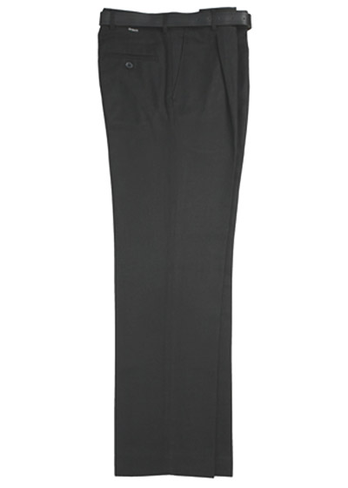
- The material must not be denim.
- A jean style cut (with rear patch pockets and rear yoke seam) is not allowed.
- They must be without ornate decorative buttons.
- Leg width to be neither “skinny cut” nor excessively baggy.
- To be worn on the waist, not low slung below it and of full length.
- Belts are to be plain black with simple buckle – No themed or stylised buckles.
- Smart tailored shorts, hemmed (not rolled or turned up)

Plain black regulation skirt if not in trousers.
Skirt Regulations:
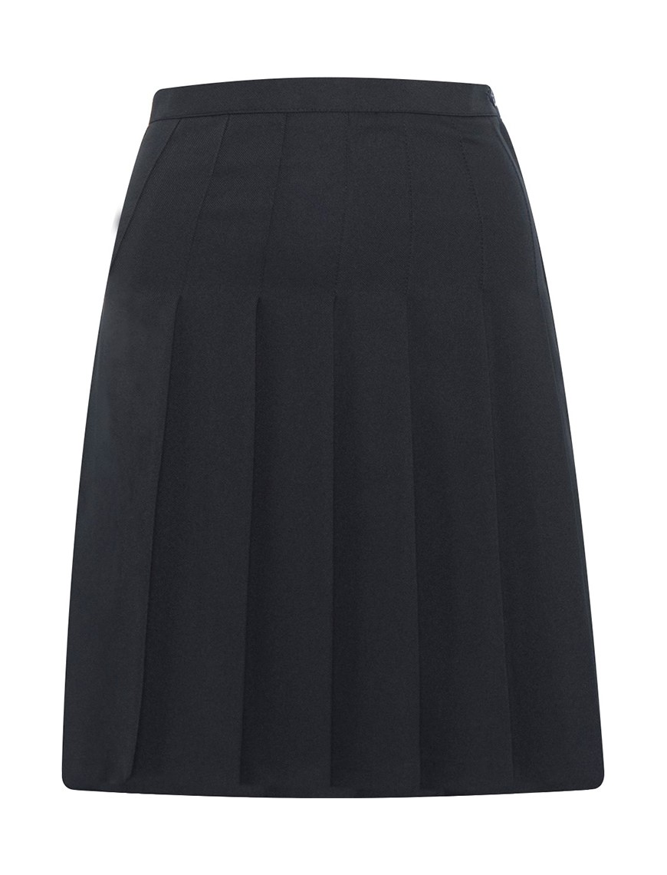
Style
- ‘A’ line, straight or pleated styles, in one continuous material.
- Ra-Ra type skirts or stretch jersey knit are unacceptable.
- Year 7 will be issued with the new College skirt with College logo
Length
- Knee length, no shorter than the top of the knee and no lower than the bottom of the knee.
Finish detail
- No additional detailing on the skirt such as zips on pockets, patches etc.
- If belts are worn they should be narrow and plain black with a simple buckle. Logos on belts and buckles are unacceptable.
Hosiery
- The skirt should be worn with plain black socks. Alternatively, plain black tights may be worn. No leggings to be worn under skirts.
Shoes:
Plain, black shoes should be worn. Ankle boots (flat soled) are acceptable only if they are plain black polished leather, not suede “UGG” style and are able to be worn inside trousers. High cut/laced boots are not appropriate if worn with skirts. Students can wear black ankle boots with skirts as long as they are smart slip on boots. Students are not allowed to wear ‘Dr Marten’ style boots.
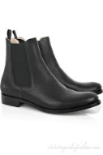
- Plain black socks only
- Smart tailored shorts, hemmed (not rolled or turned up)
- Waterproof/windproof outdoor coat big enough to wear over the blazer. No hoody style jackets.

It is not acceptable for students to wear:

- Hooded tops, cardigans, knitted jackets, heavy weight over shirts, vest tops/t-shirts, tank tops worn over the shirt
- Jeans, informal/skinny trousers or leggings
- Trainers (unless completely black with no coloured logos), flip flops, open toe shoes/sandals
- Coloured logos
- Coloured undershirts, polo shirts
- The wearing of hats, scarves and outside coats indoors
- Rolled up blazer sleeves and trouser legs
- Rolled up trousers to create shorts
Makeup, hair & jewellery:
- A watch, a small single stud per ear and a plain signet ring

Uniform is formal and as such students must not wear or appear to have:
- Extreme or excessive make-up, false eyelashes
- Nail varnish, false nails, acrylic and gel nail tips and extensions
- Necklaces, bracelets, anklets, charity bands (this is also for health and safety reasons as they are inappropriate in many lessons and can get caught easily)
- Non-College badges
- Facial studs, tongue piercings, body piercing and exaggerated, decorative flesh tubes (including clear tubes, studs and retainers)
- Extreme hair colour, style or cut (no shorter than a grade 2). Exceptions will be made for students who have exceptional circumstances due to medical reasons
- Large hair accessories
- Visible Henna, including "black henna" or "neutral henna" tattoos

