South Dartmoor – Supporting Transgender Children
ONE MINUTE GUIDE

- What is gender identity?

For some people, it is not appropriate to think of gender identity as being totally female or totally male. They may consider their gender identity to be fluid, partially male and partially female or they may consider themselves to be ungendered. When the person experiences a discomfort or distress at the mismatch between their gender identity and physical sex it is referred to as gender dysphoria. The important thing is to validate the young person’s identity as it is now and support any changes that may arise as they come to explore their gender identity further.

- Transgender/Trans/trans

These are umbrella terms used to describe people who identify as:

- Transgender (gender expression that differs from assigned sex)
- Transsexual (people whose gendered identity differs from their assigned sex and who actively seek a transition into the gender they feel identify with normally by following medical treatment)
- Transvestite (a person who wears the clothes of the opposite sex, and acts in that manner)
- Intersex refers to someone who is born with genital ambiguity.
- Non-Binary (Neither male nor female). This can be either a transitional gender status or a permanent one depending on the person.
- Gender fluid (gender changes between male and female repeatedly)
- Androgynous (partly male and female in appearance)
- A third gender, where individuals are categorized, either by themselves or by society, as neither man or woman. The term third is usually understood to mean "other"
- Or who have a gender identity which we do not yet have words to describe.

Transgender Person: A person whose gender identity is different from the sex they were assigned at birth. Some transgender people will choose to transition socially and some will also take medical steps to physically transition (with the help of hormone therapy and/or surgery) to live in the gender role of their choice.

Transsexual Person: A person with a consistent and overwhelming desire to transition and fulfil their life as the opposite gender. Most transsexual people actively desire and complete gender re-assignment surgery.

- Why is this important?
Transgender children and young people are a particularly vulnerable group. Someone whose gender presentation appears different from their biological sex could be vulnerable to transphobic bullying but could also suffer from homophobic or sexist and sexual bullying.
- Seating plans - Students often report that boy-girl seating is the most frequent cause of stress. For non-binary students (those who identify as neither male nor female), such arrangements erase their gender entirely; therefore, avoid this method of seating pupils

- Recognise and challenge transphobia - Many schools are now appropriately challenging homophobic language, but we are less skilled at challenging – or even identifying – transphobia. Most common is students misgendering one another as “banter”. The key is in educating students as to why this is harmful. Once explained, adopt a zero-tolerance policy on future transphobia.

- Names - It’s important to honour students’ choices of name – for transgender students, this sends the important message that you accept their identities unfailingly. In those cases, it is important that the student feels free to ask to be addressed as a “he”, “she” or by their own name. Transgender students will appreciate a member of staff asking kindly about how they would prefer to be addressed as.

- Ensure safe spaces for Trans students - Toilet and changing room access for Trans students can be difficult. In the short term schools can turn disabled toilets into gender neutral bathrooms to create a safe space. Long term a toilet specifically designated as a gender neutral toilet is generally best and something to be considered.

- Curriculum - Hearing about transgender people in lessons can provide trans and cisgender students alike with role models.

- Assembly and tutorial time - Use assembly and from time to raise awareness of key dates for the trans community.

- Support and guidance

Sexualities and gender equality community group

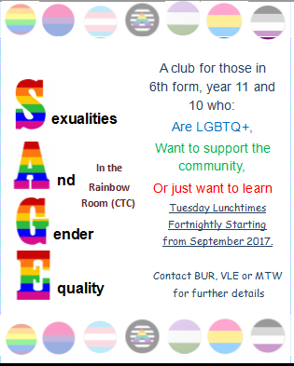

The Intercom Trust is a lesbian, gay, bisexual and trans community resource in Cornwall, Devon, Dorset and the wider South West.
The trust provide help against homophobic and transphobic prejudice, crime and discrimination (including bullying, harassment, abuse, attacks, and threatening behaviour), helping to develop the LGBT communities, providing professional training and consultancy, and working in partnership with local government, the police, health and other organisations.
Helpline 0800 612 3010

